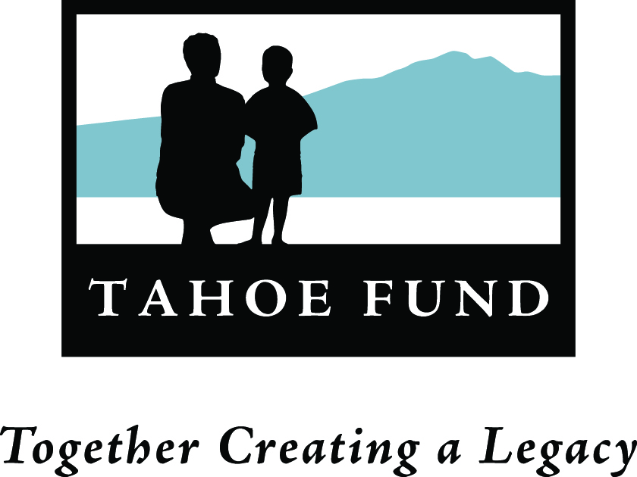
M e m o r a n d u m
TO: Board of Directors
FROM: Cindy Gustafson
DATE: November 9, 2011
RE: Committees

In continuation of our process to organize and develop the capacity of the Tahoe Fund we ask that each of you consider joining a committee of the Board. Committees will develop policy and work plan recommendations for the approval of the Executive Committee and the full Board of Directors. Below is a list of the committees with a list of current and future responsibilities. Please let me know if you would be interested in serving on a committee.

Organizational Development (Exec Committee) - Officers and up to two additional members
- Recruit, hire, and oversee the executive director and staff
- Plan and conduct an organizational retreat
- Establish committees and approve workplans
- Recruit additional board members
- Establish back-office operations with supporting organization
- Oversee budget and financial resources of the organization

Fundraising (Development Committee)
- Organize end of year campaign
- Organize Bay Area spring events
- Begin planning for August events
- Launch Tips for Tahoe program
- Approach key donors, corporations, foundations, etc.

Outreach/Communications (Communications Committee)
- Maintain/update website
- Develop online marketing materials
- Develop license plate marketing and promotional materials (with CTC funding)
- Develop Tips for Tahoe marketing and promotional materials

Projects (Projects Committee)
- Establish process for identifying, selecting and funding projects
- Establish funding coalition to help identify projects and support public funding efforts

Audit Committee
- Recommends hiring of, and reviews the work of independent auditor
- Ensures that the financial affairs of the corporation are in order
- Ensures that the auditor complies with Government Auditing Standards published by the Comptroller General of the United States, or any standards promulgated by the Attorney General of California or the State of Nevada.

