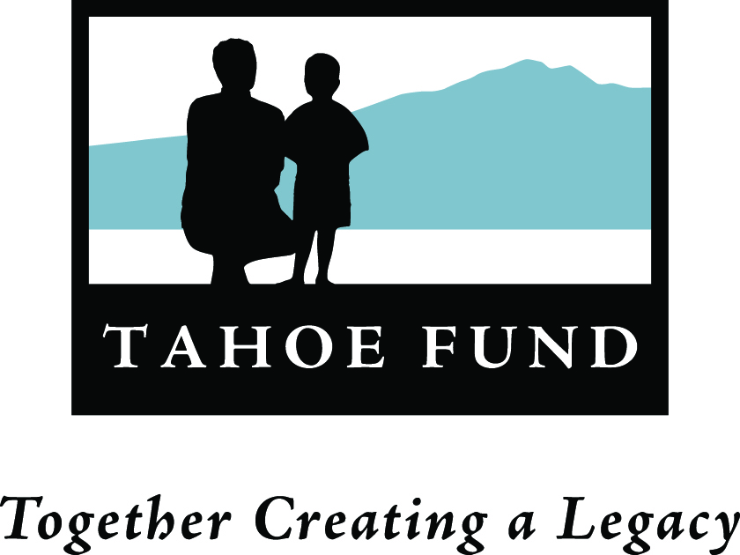
M e m o r a n d u m
TO: Board of Directors
FROM: Cindy Gustafson
DATE: November 9, 2011
RE: Bylaw Changes

RECOMMENDATION:
The Executive Committee has discussed several amendments to our adopted bylaws and recommends the following changes which are included in the red-line version attached.
- Article 1 - Name Change from “Lake Tahoe Conservation Fund” as it shown in all of our official documents to “Tahoe Fund”. When we formed the organization we named it the “Lake Tahoe Conservation Fund”. Subsequently, during development of the logo and literature we started using the shortened “Tahoe Fund”. For a number of reasons both official and practical it would be better to have the official name match the name known in public. The name “Tahoe Fund” is available in California but has a conflict in Nevada with an investment fund registered with the name. We are attempting to gain their permission to use the name and if granted permission would like to act to change the name with Nevada, California, and the IRS.
- Article 7, Section 3 - Directors’ terms of offices. Change in terms from 2 year terms to 3 years, and changing the original terms from 1 and 2 years to 2 and 3 years.
- Article 7, Section 5 - Meetings. Change the location to Parasol’s offices.
- Article 7, Section 6 - Action at a Meeting. Change the quorum requirement to 1/3 + 1 of the currently seated number of Directors.
- Article 9 - Committees. Amending language to be consistent with the above change in definition of quorum.
- Article 12, Section 4 - Preparation of Financial Statements. Adding the State of Nevada.
- Article 14, Amendments and Revisions. Amending language to be consistent with changes in quorum requirement.

