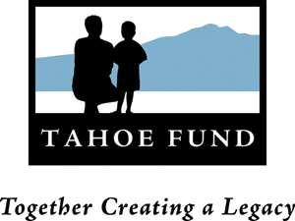
Tahoe Fund Board Meeting
November 11, 2011
Parasol Tahoe Community Foundation
2:00 – 5:00 pm

2:00 – 2:05 Introductions (5 min)

2:05 – 2:10 Tahoe Fund History (Cindy - 5 min)

2:10 – 2:40 Budget Update – (Cindy - 30 min)

2:40 – 2:55 Discussion and approval of the Conservation Strategy Group (CSG) contract - action
(Patrick - 15 min)

2:55 – 3:10 Bylaw Changes – action (Cindy - 15 min)
- Name
- Quorum
- Terms

3:10 – 3:15 Election of Officers – action (Cory - 5 min)

3:15 – 3:35 Designation of Director Terms – action (Cindy - 20 min)

3:35 – 4:05 Committee Updates (30 minutes)
- Communications
- Projects
- Development
- Executive Committee
  - Executive Director/CEO search

4:05 – 4:25 Committee Selection – action (Cindy - 20 min)

4:25– 4:35 Calendar of Board Meetings – action (Allen - 10 min)

4: 35– 4:45 California Tahoe Conservancy License Plate Contract – action (Cindy – 10 minutes)

4:45 – 4:55 Authorization by the Board of the Executive Committee to enter into contracts – action
(Cindy - 10 minutes)

4:55 – Closing Remarks

